**IDEATION PHASE**

**Brainstorm & Idea Prioritization**

**Date:** 19-06-2025

**Team ID:** LTVIP2025TMID28970

**Project Name**: Garage Management System

**Objective:**

Brainstorming enables collaborative ideation in identifying pain points and potential solutions. It fosters creativity, encourages multiple viewpoints, and helps prioritize solutions based on feasibility and impact.

**Step 1: Team Gathering, Collaboration and Problem Identification**

The team engaged with automotive garage staff, mechanics, and service managers to identify key operational challenges. Based on discussions and on-site observations, the following issues were highlighted:

* Manual job card creation and tracking
* Inefficient appointment booking process
* Lack of real-time updates on vehicle servicing status
* Inconsistent communication with customers
* Difficulty tracking spare parts inventory
* Absence of centralized records and reporting

**Selected Problem Statement:**

**"A garage lacks a centralized digital system to manage appointments, service records, inventory, and customer communication effectively."**

**Step 2: Brainstorming, Idea Listing and Grouping**

Raw Ideas Collected:

* Digital appointment booking with time slot allocation
* Service card automation and record generation
* Track vehicle service history and parts replaced
* Real-time service status updates to customers
* Inventory module for managing spare parts
* Role-based access for receptionist, mechanic, and admin
* Custom reports and dashboards for service trends
* Validation rules for missing fields and inconsistent data
* Automated email/SMS reminders for appointments and status

**Grouped Ideas:**

1. **Automation**
   * Auto-generate service card and service ID
   * Auto-update job status on completion
2. **Inventory Management**
   * Spare parts usage log
   * Stock alerts and reorder levels
3. **Role-Based Access**
   * Worker Separate dashboards for admin, mechanic, and receptionist
   * Profile-based permissions
4. **Reporting & Visualization**
   * Service type frequency reports
   * Inventory usage and appointment history
5. **Customer Communication**
   * Email/SMS notifications for booking, completion
   * Reminders and follow-ups

**Step 3: Idea Prioritization**

|  |  |  |  |
| --- | --- | --- | --- |
| **Idea** | **Impact** | **Feasibility** | **Priority** |
| Auto service card | High | High | High |
| Live service status | High | Medium | High |
| Inventory module | Medium | High | Medium |
| Custom roles | Medium | Medium | Medium |
| Email reminders | High | High | High |
| Validation rules | High | High | High |

**Final Shortlisted Ideas (with More Detailed Explanation):**

**1. Auto Service Card Creation and Status Updates**

This feature streamlines the garage workflow by automatically generating a digital service card when an appointment is scheduled. It includes critical information such as:

* Customer and vehicle details
* Type of service requested (regular, urgent, warranty)
* Assigned technician and bay number
* Time and date stamps

As service progresses, technicians can update the card to reflect the current status (e.g., **Inspection Complete**, **Parts Replaced**, **Final Check**, **Ready for Delivery**). These updates provide **real-time visibility** for the receptionist and the customer, reducing miscommunication and improving transparency. Additionally, the service history is saved for future reference, enabling recurring customer benefits and tracking long-term vehicle performance.

**2. Record-Triggered Flow to Notify Customer**

Improving customer communication is vital in maintaining trust and satisfaction. This flow automatically sends:

* Appointment confirmations with expected service start time
* Notifications when service moves to new stages (e.g., In Progress, Completed)
* Alerts for delays with revised delivery estimates
* Personalized messages on birthdays or service anniversaries

Messages are sent via **email or SMS** and are dynamically filled with **customer and vehicle-specific data**. All notification attempts are logged with delivery status. Failed messages are flagged for manual follow-up, ensuring no customer is left uninformed.

**3. Spare Parts Inventory Management**

This module automates tracking of consumable and non-consumable parts in the garage:

* Each part has attributes like part number, description, compatibility, current stock, reorder level, and supplier info
* When a part is used during service, it is automatically deducted from stock
* When the stock falls below a predefined level, notifications are triggered for reorder
* Supports purchase orders, supplier management, and part return logs

The system provides insights into **fast-moving and slow-moving parts** and ensures parts are always available, **reducing service delays**.

**4. Custom Reports and Dashboards**

Decision-makers need actionable insights to improve efficiency and profitability. Custom reports and dashboards can display:

* Mechanic efficiency (average service time, job completion rate)
* Service demand trends (popular service types per week/month)
* Inventory cost tracking and wastage analytics
* Appointment trends (peak booking hours, cancellations)

Dashboards are **visual and interactive**, allowing managers to filter by technician, date, service type, and more. Reports can be **scheduled or exported** for sharing during team reviews or audits.

**5. Role-Based Access Control**

Security and clarity are enhanced through tailored system access:

* **Receptionists** can manage customer intake and appointments but cannot see financial or inventory modules
* **Mechanics** can access job cards and update service status but not customer billing
* **Inventory Managers** manage parts and orders, without access to customer records
* **Admins** oversee all functions, manage users, configure workflows, and run reports

Each role sees only what they need, preventing errors and boosting efficiency. **Audit logs** track who changed what, helping maintain accountability and transparency.

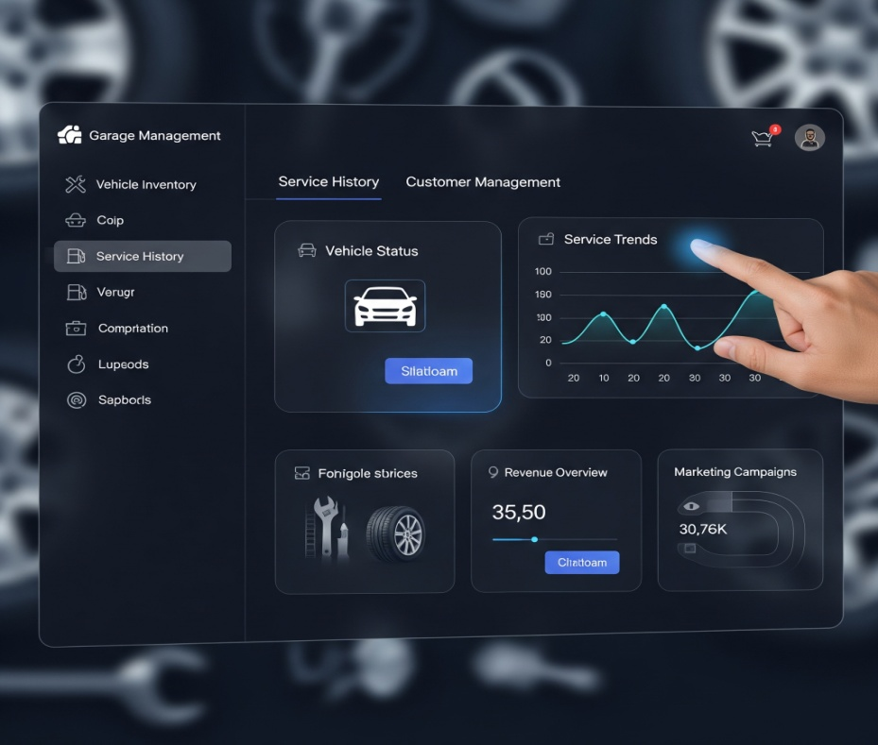

**Empathy Map Canvas**

The Empathy Map Canvas serves as a powerful tool to step into the shoes of your target users, understanding their world beyond just explicit requirements. By exploring what users **say**, **think**, **do**, and **feel**, we gain deeper insights into their needs, pain points, and motivations—crucial for designing a truly effective garage management solution.

### ****Who are we empathizing with?****

**1. Garage Owners / Managers:**  
They are responsible for business performance, customer satisfaction, resource management, and service quality. Their concerns include revenue tracking, appointment scheduling, inventory usage, mechanic performance, and ensuring smooth customer interactions. They need a system that provides comprehensive visibility, simplifies oversight, and supports strategic decisions.

**2. Front Desk Staff / Service Advisors:**  
These staff are the first point of contact for customers and are responsible for creating appointments, generating job cards, communicating service status, handling billing, and coordinating between customers and technicians. Their challenges often revolve around manual data entry, repetitive phone calls, and tracking service progress without a centralized tool.

### ****User Says (What the user verbalizes)****

* **"I want to track all appointments and services without confusion."**  
  Implication: This implies a need for a centralized calendar/scheduling system with clear visual indicators for booked, ongoing, and completed services.
* **"Customers keep calling to ask about their vehicle status."**  
  Implication: This shows a gap in communication. There's a need for automated status updates, perhaps via SMS or email, to reduce manual follow-up and enhance the customer experience.

### ****User Thinks (What the user is pondering, but not necessarily verbalizing)****

* **"There should be an easier way to manage job cards and service history."**  
  Implication: They're tired of digging through papers or Excel files. A digital record system that links customer history, vehicle details, and past services would significantly reduce workload.
* **"Inventory is often missing when I need it the most."**  
  Implication: Suggests reactive inventory management. A real-time inventory system with stock alerts and usage tracking is needed to avoid service delays.

### ****User Does (What actions the user takes)****

* **Maintains handwritten notebooks or Excel sheets for service details**  
  Implication: This manual process is error-prone, unsearchable, and difficult to share. It indicates the need for a structured, accessible, and cloud-based service record system.
* **Makes repeated calls to confirm appointments or status**  
  Implication: This time-consuming task highlights the need for an integrated customer communication system that automates reminders and status notifications.

### ****User Feels (What emotions the user experiences)****

* **Frustrated with misplaced service records or forgotten follow-ups**  
  Implication: Points to disorganized record-keeping and the absence of workflow automation. It increases operational stress and customer dissatisfaction.
* **Satisfied when service flow is smooth and customers don’t complain**  
  Implication: This reinforces that transparency and operational efficiency lead to job satisfaction and business growth. A good system that automates updates and provides visibility supports this feeling.

### ****Insights Gained:****

#### ****1. Need for Centralized Job and Customer Record Management****

* **Detailed Insight:** Disconnected notebooks, paper job cards, and Excel sheets make tracking inefficient and risky. A centralized system should store customer data, vehicle history, service records, and appointment details.
* **Direct Impact on Solution:**  
  Introduce custom objects in the CRM like Customer, Vehicle, Appointment, and Service Record. These must be interlinked and searchable, forming the core of the Garage Management System (GMS).

#### ****2. Communication Automation Is Key to Time Efficiency and Customer Trust****

* **Detailed Insight:** Manual follow-ups consume time and are inconsistent. Customers expect timely updates, especially when their vehicle is under service.
* **Direct Impact on Solution:**  
  Implement **Record-Triggered Flows**, **Email Alerts**, and **SMS Integrations** to automatically inform customers about:
  + Appointment confirmation
  + Service started/completed
  + Invoice generation
  + Payment reminders  
    Templates should be personalized using merge fields (e.g., customer name, vehicle number, service status).

#### ****3. Inventory Management Needs Real-Time Visibility****

* **Detailed Insight:** Lack of real-time inventory tracking leads to part shortages, service delays, and customer dissatisfaction.
* **Direct Impact on Solution:**  
  Develop an Inventory object with attributes like item name, part number, quantity in stock, and reorder levels. Automatically deduct part quantities during job completion and trigger low-stock alerts for restocking.

#### ****4. Dashboard & Reports for Performance Tracking****

* **Detailed Insight:** Owners and managers want visibility into operations, revenue, service performance, and inventory usage without digging into raw data.
* **Direct Impact on Solution:**  
  Build **custom dashboards** to show:
  + Total bookings this month
  + Revenue generated
  + Average service time
  + Part usage trends  
    Use **custom reports** for service records, inventory flow, and customer frequency.

#### ****5. Role-Based Access Is Essential for Security and Focus****

* **Detailed Insight:** Not all users need access to all data. Simplified, role-based views prevent confusion and ensure privacy.
* **Direct Impact on Solution:**  
  Define **Profiles** and **Permission Sets** for:
  + **Receptionists:** Can create/edit appointments and basic customer info.
  + **Technicians:** Can view assigned jobs and update job card status.
  + **Inventory Managers:** Can manage parts and suppliers.
  + **Admin:** Full access to all modules and reports.

**Customer Problem Statements**

**Problem Statement 1: Operational Inefficiencies and Customer Service Challenges for Garage Staff and Management**

**Problem Statement:**  
We believe that garage staff and management are struggling with effectively handling customer appointments, vehicle service tracking, and billing because of fragmented manual processes and lack of real-time data visibility. This causes delays in service delivery, miscommunication with customers, billing errors, and reduced productivity across the garage.

**Elaboration:**

* **Customer Type:** Garage managers, service advisors, mechanics, and front-desk staff.
* **Core Problem:** Ineffective handling of service operations due to scattered or non-digital workflows.
* **Root Causes:**
  + Lack of an integrated digital platform to track customer records, vehicle history, and service details.
  + Heavy reliance on manual tools like registers, phone calls, and basic spreadsheets.
* **Negative Impacts:**
  + **Delays in service delivery:** Staff must manually check service queues or records, causing confusion or missed services.
  + **Billing errors:** Miscommunication between the service team and the billing desk often leads to missed items on invoices or incorrect pricing.
  + **Reduced productivity:** Staff spends time on routine coordination tasks (e.g., checking availability, finding past records) instead of focusing on quality service.
  + **Miscommunication with customers:** Without a centralized system, staff cannot easily update customers on service status or estimated time of completion.

**Problem Statement 2: Lack of Transparency and Convenience for Vehicle Owners**  
We believe that vehicle owners are struggling with a lack of real-time updates and transparency regarding their service appointments and repair progress because of limited digital communication channels and disconnected internal tracking systems. This causes uncertainty, unnecessary phone calls or visits, and a poor customer experience that can damage trust in the garage.

**Elaboration:**

* **Customer Type:** End-users of garage services – private car owners, fleet operators, etc.
* **Core Problem:** Customers lack access to timely, accurate service status updates.
* **Root Causes:**
  + No automated update mechanism (e.g., SMS, email, app notifications) about vehicle repair status or billing.
  + Internal service tracking is not connected to customer-facing systems, making it hard to share updates promptly.
* **Negative Impacts:**
  + **Uncertainty and frustration:** Vehicle owners are often unsure when their vehicle will be ready or what stage it's currently in.
  + **Unnecessary follow-ups:** Customers must call or visit the garage to check the status, wasting their time and the staff’s.
  + **Decreased trust and satisfaction:** A lack of professional communication and visibility lowers customer confidence and discourages repeat business.

**Problem Statement 3: Missed Opportunities for Business Growth Due to Lack of Data-Driven Insights**  
We believe that garage owners and decision-makers are struggling with making informed business decisions because of the absence of centralized, actionable data about customer behavior, service trends, and financial performance. This causes missed up-selling opportunities, poor resource allocation, and limited strategic growth.

**Elaboration:**

* **Customer Type:** Garage owners, business analysts, operations managers.
* **Core Problem:** Limited access to consolidated data that can drive strategic improvements.
* **Root Causes:**
  + No structured data collection from appointments, services, customer feedback, etc.
  + Manual record-keeping makes trend analysis or performance reporting time-consuming and error-prone.
* **Negative Impacts:**
  + **Missed up-selling opportunities:** Without visibility into customer history, staff can't suggest additional services or timely reminders.
  + **Poor resource management:** Inability to forecast demand leads to overstaffing or under-utilization.
  + **Limited business growth:** Lack of insights means decisions are made based on guesswork, not data.